Speak-Ease
Introduction
Speak-Ease is a versatile and user-friendly gamified language learning platform designed to make language acquisition engaging, interactive, and fun. Inspired by Duolingo, it combines modern web technologies with proven educational principles to create an immersive learning experience that motivates users through gamification mechanics, community features, and structured content delivery.

1. Scenario-Based Case Study
Meet Priya, a 28-year-old marketing professional living in India with a passion for travel and cultural exploration. She dreams of becoming fluent in Spanish to communicate with colleagues in her company’s Madrid office and to travel throughout Latin America. Despite her strong motivation, her busy work schedule makes it difficult to commit to traditional language classes.

1.1 The Challenge
• Limited time — Can only study during lunch breaks and evening commutes
• Lack of engagement — Traditional textbooks feel boring and disconnected
• No clear progress — Difficult to measure learning outcomes
• Motivation issues — Tendency to lose interest without visible rewards

1.2 How Speak-Ease Transforms Her Learning
Priya discovers Speak-Ease, a comprehensive web application designed to streamline language learning operations. Intrigued by its features, Priya decides to explore how Speak-Ease can help her enhance her productivity and effectiveness.

1.2.1 User Registration and Interactive Learning
Priya creates an account on Speak-Ease, providing her email and password, and imme- diately accesses the platform. She is greeted with a beautiful landing page showcasing multiple language courses. She selects the Spanish course and starts with the first unit. Each lesson includes interactive challenges through multiple-choice questions, audio exer- cises, and translation challenges. When she completes a challenge correctly, she earns XP (experience points) and feels a sense of accomplishment.

1.2.2 Progress Tracking and Community Engagement
Speak-Ease offers a comprehensive progress tracking system that allows Priya to monitor her learning journey efficiently. She can track her completion statistics, analyze learning trends, and identify opportunities for improvement. After completing multiple lessons, Priya checks the leaderboard feature and sees her username has climbed to the top 50 globally, motivating her to study more consistently.

1.2.3 Gamification and Rewards
The platform rewards Priya with 5 hearts at the start. When she answers incorrectly, she loses one heart, creating a game-like environment that keeps her engaged. She discovers the shop feature and sees that with her earned XP, she can purchase cosmetic items. She completes her first weekly quest and earns bonus XP and a special badge.

1.2.4 Priya’s Experience
Thanks to Speak-Ease, Priya can now manage her language learning activities more efficiently and effectively. She can focus on building strong communication skills, mastering language fundamentals, and achieving her learning goals. After consistently using Speak- Ease for a month, Priya earns 10,000 XP, reaches level 15, and holds a position in the top 100 on the global leaderboard. Speak-Ease has become an indispensable tool in her learning journey, helping her achieve her professional goals with ease and confidence.
To ensure smooth development, deployment, and usage of the Speak-Ease Web Application, certain system prerequisites must be met. These requirements are categorized into software, setup, and hardware specifications.

2.1 Software Requirements
These are the essential tools and platforms required to develop, test, and run the application efficiently.
• Operating System: Windows 10/11, macOS, or Linux — Supports cross-platform development and testing
• Node.js (v16 or above): Provides the runtime environment for building and managing frontend logic and powers the server-side logic
• npm (v8 or above): A package manager required to install dependencies for React and related libraries
• React.js: A JavaScript library for building dynamic and responsive user interfaces
• Browser: Google Chrome / Firefox (latest version) — For rendering and testing the UI in real-time
• Express.js: A lightweight web framework for building RESTful APIs
• MongoDB: A NoSQL database used to store structured and unstructured data
• Postman: Tool for testing APIs during development
• Visual Studio Code: Preferred code editor with built-in Git and terminal support

2.2 Hardware Requirements
Describes the minimum and recommended specifications needed to support the develop- ment and usage of the application.
• Processor: Intel Core i5 (8th Gen or above) / AMD Ryzen 5 or better
• RAM: Minimum 8 GB (16 GB recommended)
• Storage: At least 5 GB free space
• Display: 1920×1080 or higher

3.1 Technical Architecture
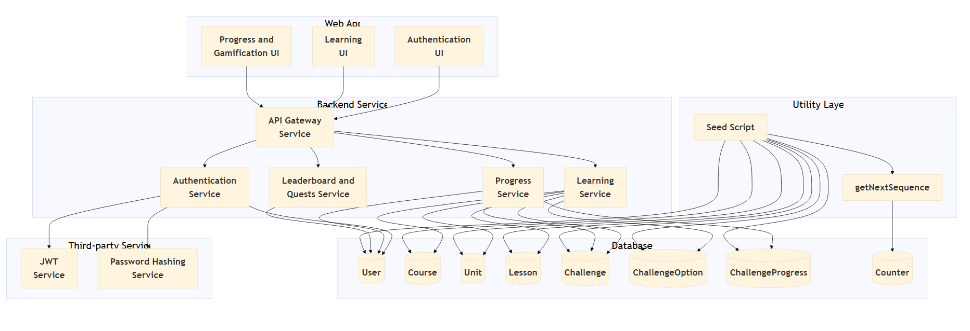

The Speak-Ease platform follows a comprehensive multi-layered architecture that ensures scalability, maintainability, and optimal performance. The system is designed with clear separation of concerns across the presentation layer, API gateway, business logic layer, data access layer, and database layer.
[Architecture Diagram: Frontend → Backend → Database flow with service layers]
In this architecture, the flow begins with a user interacting with the Speak-Ease frontend (represented by the React application). The user submits requests through the frontend interface, which then communicates with the Express.js backend through RESTful APIs.
The backend processes the request and the associated data through various service layers. The backend communicates with a MongoDB database to store user progress, course content, and all application data securely. The database stores the submitted data, including user responses, XP earned, and progress tracking.
Once the backend has processed the request, it sends a JSON response back to the frontend. The frontend then displays the updated data to the user, creating a seamless and interactive learning experience.

[ER Diagram: Shows 8 entities — User, Course, Unit, Lesson, Challenge, ChallengeOption, ChallengeProgress, Counter with their relationships]
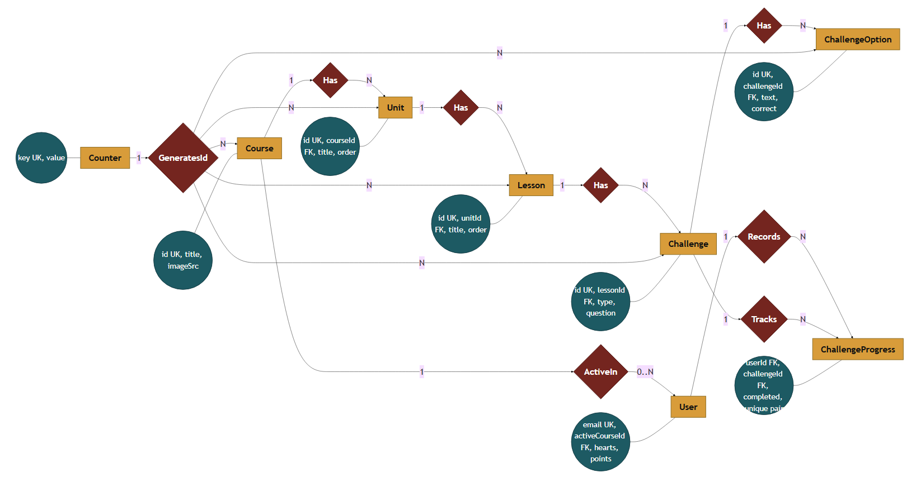
4. ER Diagram

The Entity-Relationship (ER) diagram for Speak-Ease represents the various entities and their relationships within the language learning system.

4.1 Entities
• User: Represents users who learn languages, with attributes such as user ID, email, password, activeCourseId, hearts, and points
• Course: Represents language courses available in the system, with attributes such as course ID, title, and imageSrc
• Unit: Represents units within courses, with attributes such as unit ID, courseId, title, and order
• Lesson: Represents lessons within units, with attributes such as lesson ID, unitId, title, and order
• Challenge: Represents individual challenges/questions, with attributes such as chal- lenge ID, lessonId, type, and question
• ChallengeOption: Represents answer options for challenges, with attributes such as option ID, challengeId, text, and correct
• ChallengeProgress: Represents user progress on challenges, with attributes userId, challengeId, and completed
• Counter: Represents auto-incrementing ID counters, with attributes key and value

4.2 Relationships
• Course → Unit: One-to-Many relationship indicating which units belong to each course
• Unit → Lesson: One-to-Many relationship indicating which lessons belong to each unit
• Lesson → Challenge: One-to-Many relationship indicating which challenges belong to each lesson
• Challenge → ChallengeOption: One-to-Many relationship indicating which options belong to each challenge
• User → ChallengeProgress: One-to-Many relationship tracking user progress on challenges

4.3 Attributes
Each entity has its own set of attributes that describe its properties. For example, the User entity has attributes such as email, password, activeCourseId, hearts, and points.

4.4 Primary Keys
Each entity has a primary key that uniquely identifies each record. For example, the User entity’s primary key is the user ID (ObjectId in MongoDB).

4.5 Foreign Keys
Foreign keys are used to establish relationships between entities. For example, the Unit entity has a foreign key courseId that references the Course entity to link units to courses.
Overall, the ER diagram for Speak-Ease provides a visual representation of the database schema, showing how different entities are related and how data flows between them in the language learning system.

5. Key Features
The key features of the Speak-Ease language learning platform include:

5.1 User Registration and Profiles
Allow users to create accounts, set up profiles, and manage their personal information. Secure authentication using JWT tokens and password hashing.

5.2 Course Management
Allow users to browse and select language courses based on their preferences. Structured organization with courses, units, and lessons for progressive learning.

5.3 Interactive Challenges
Multiple choice questions, audio exercises, and translation challenges. Instant feedback on answers with XP rewards for correct answers.

5.4 Gamification System
XP (Experience Points) for progress, hearts/lives system, user level progression, streak tracking, and achievement badges.

5.5 Progress Tracking
Maintain a record of learning progress, completion percentages, and statistics. Users can track their advancement and identify areas for improvement.

5.6 Leaderboard
Global user rankings based on XP, top performers visibility, and competitive engagement mechanism.

5.7 Shop and Rewards
Purchase cosmetic items and themes with earned XP, avatar customization, and sense of achievement.

5.8 Quests and Achievements
Daily and weekly challenges with specific objectives, bonus XP for quest completion, and special badges for achievements.

6.1 User
• Registration and Account Management: Users are responsible for creating an account, providing accurate personal information, and managing their account details, including profile updates and password security
• Learning and Progress: Users can select language courses, complete lessons and challenges, earn XP, and track their learning progress
• Engagement: Users may participate in daily quests, check leaderboards, and purchase items from the shop using earned XP
• Communication: Users should provide honest feedback on courses and challenges to help improve the platform
• Feedback and Reviews: Users have the responsibility to provide constructive feedback on the learning experience

6.2 Admin
• System Management: The admin is responsible for overall management and admin- istration of the Speak-Ease platform. This includes monitoring system performance, ensuring data security and privacy, and managing app settings and configurations
• User Management: The admin is responsible for managing user accounts, including registration, verification, and account moderation
• Content Management: The admin oversees the creation and management of courses, units, lessons, and challenges. They ensure the accuracy and quality of educational content

[User Flow Diagram: Shows authentication → course selection → learning flow →
challenge flow → engagement flow]

7.1 User Flow
• Registration & Account: Create and manage account details securely with email and password
• Course Selection: Browse available courses and select a language to learn
• Learning: Access units and lessons, complete interactive challenges
• Progress Tracking: Monitor completion percentages, XP earned, and learning statistics
• Engagement: Check leaderboards, complete quests, and purchase shop items

7.2 Admin Flow
• System Management: Oversee app performance, settings, and security
• User Management: Verify, approve, suspend, or manage user accounts
• Content Management: Create and maintain courses, units, lessons, and challenges

MVC Diagram
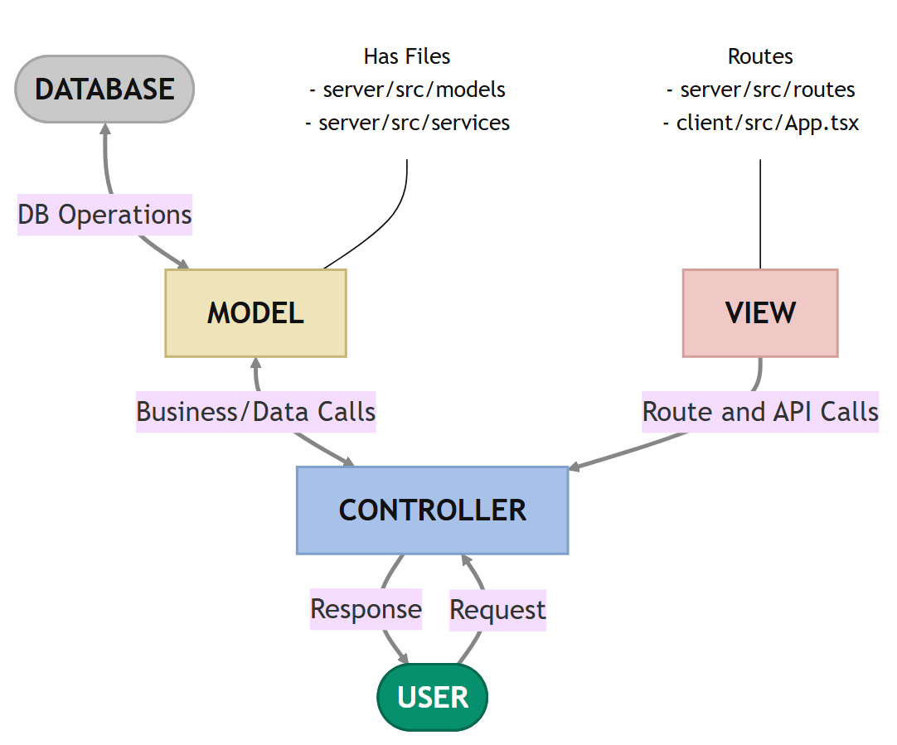
The Speak-Ease application follows the Model-View-Controller (MVC) architectural pattern, a software design approach that separates an application into three interconnected layers. This separation allows for modularity, easier maintenance, and scalability.

8.1 Model Layer (Data Layer)
The Model layer is responsible for handling all data-related logic. This includes the definition of data schemas and the operations performed on the database using those schemas. The models are implemented using Mongoose, which provides a schema-based solution to model application data for MongoDB.

8.2 Controller Layer
The Controller layer acts as an intermediary between the view (routes) and the model. It receives incoming requests, processes the input (which may include validation or transformation), calls the appropriate methods from the model, and then returns a response to the client.

8.3 View Layer (Routing Layer)
In the context of a backend REST API, the View is implemented as the routing layer, where various endpoints are defined. These endpoints determine how the backend responds to different HTTP requests (GET, POST, PUT, DELETE) and are responsible for invoking the appropriate controller functions.

8.4 Advantages of Using MVC in This Project
• Separation of Concerns: Each layer has a clearly defined responsibility, improving readability and maintainability
• Scalability: New features can be added easily by creating new routes, controllers, and models
• Reusability: Logic in controllers and models can be reused across multiple parts of the application
• Testing: Each layer can be tested independently, especially the controllers and models
• Collaboration-Friendly: Multiple developers can work simultaneously on different layers without conflict

9.1 Creating the Project Folder
• Create a new folder with your project name
• Inside that folder create two new folders: Client and Server
• Open that folder in VS Code
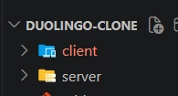

9.2 Client Setup (Installing React App)
• Open the Client folder in the terminal of VS Code
• Run: npm create vite@latest . -- --template react
• Select React framework and JavaScript variant
• Navigate to client folder: cd client
• Install packages: npm install
• Start React server: npm run dev

9.3 Server Setup
• Open Server folder in terminal: npm init -y
• Create folders: models, controllers, routes
• Install dependencies: npm install

• Create .env file with MongoDB URI, JWT secret, and port configuration

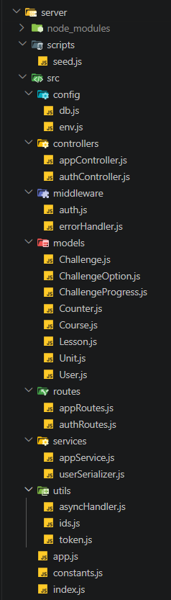
10.1 Backend Structure

The backend follows a modular architecture with clear separation of concerns.

10.1.1 Controllers
• authController.js — Handles all authentication-related business logic (signup, signin, getCurrentUser)
• appController.js — Handles all application operations (getLearnData, getCourses, getLesson, submitChallenge, etc.)
Backend Video Demo:
[Click here for the video]
10.1.2 Models
• User.js — Schema for user accounts
• Course.js — Schema for language courses
• Unit.js — Schema for course units
• Lesson.js — Schema for lessons
• Challenge.js — Schema for challenges/questions
• ChallengeOption.js — Schema for answer options
• ChallengeProgress.js — Schema for user progress tracking
• Counter.js — Schema for auto-incrementing IDs

10.1.3 Routes
• authRoutes.js — Defines API routes for authentication:
– POST /api/auth/signup
– POST /api/auth/signin
– GET /api/auth/me
• appRoutes.js — Defines API routes for application features (all protected with auth middleware)

10.1.4 Middleware
• auth.js — Authentication middleware for JWT validation
• errorHandler.js — Global error handling middleware

11. Database Development

11.1 Configure MongoDB
• Install Mongoose: npm install mongoose
• Create database connection in server/src/config/db.js
• Create Schemas & Models for all entities

11.2 Create Database Connection
The database connection is established when the server starts. Mongoose connects to MongoDB using the MONGO_URI environment variable with connection pooling for performance and error handling for connection failures.
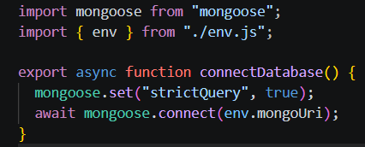

11.3 Create Schemas
Configure the Schemas for MongoDB to store data in a structured pattern. Use data from the ER diagrams to create the schemas.

11.3.1 User.js — Schema for User Accounts
Fields: email (String, unique), password (String, hashed), activeCourseId (ObjectId),
hearts (Number), points (Number), createdAt (Date)

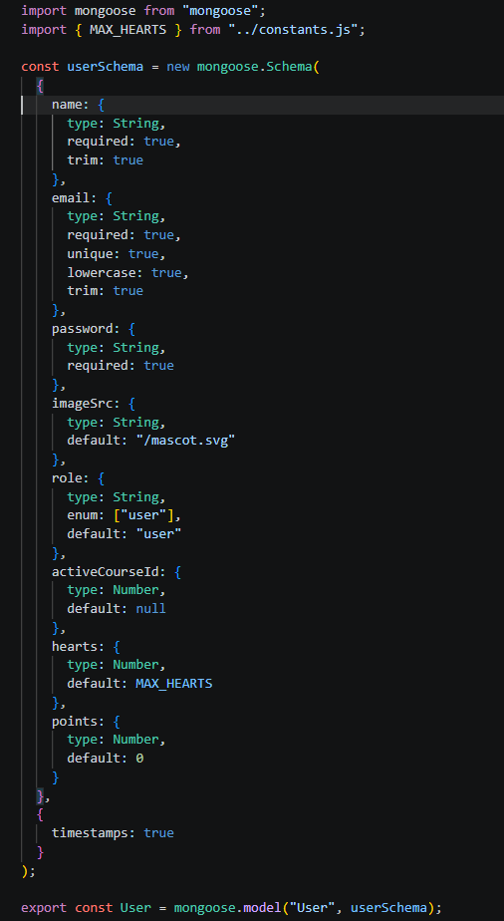
11.3.2 Course.js — Schema for Language Courses
Fields: id (Number, unique), title (String), imageSrc (String)

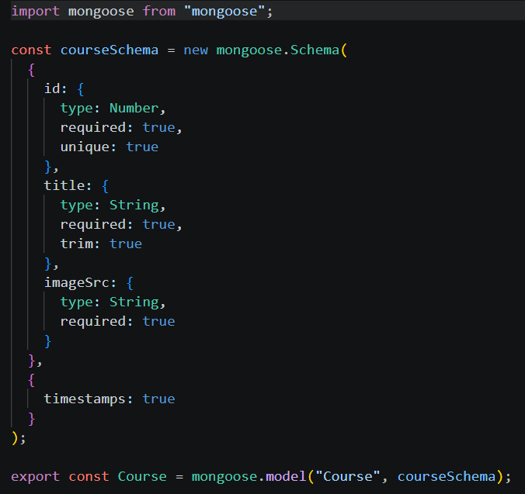

11.3.3 Unit.js — Schema for Course Units
Fields: id (Number), courseId (ObjectId, FK), title (String), order (Number)

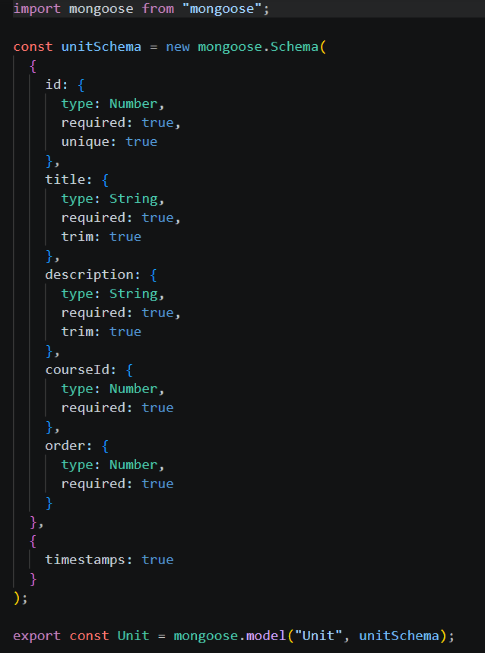

11.3.4 Lesson.js — Schema for Lessons
Fields: id (Number), unitId (ObjectId, FK), title (String), order (Number)

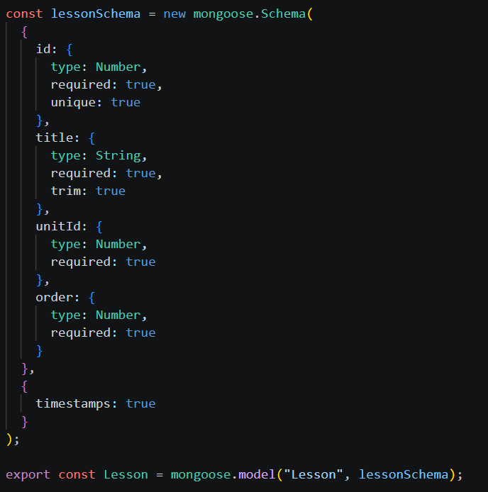

11.3.5 Challenge.js — Schema for Challenges/Questions
Fields: id (Number), lessonId (ObjectId, FK), type (String), question (String)

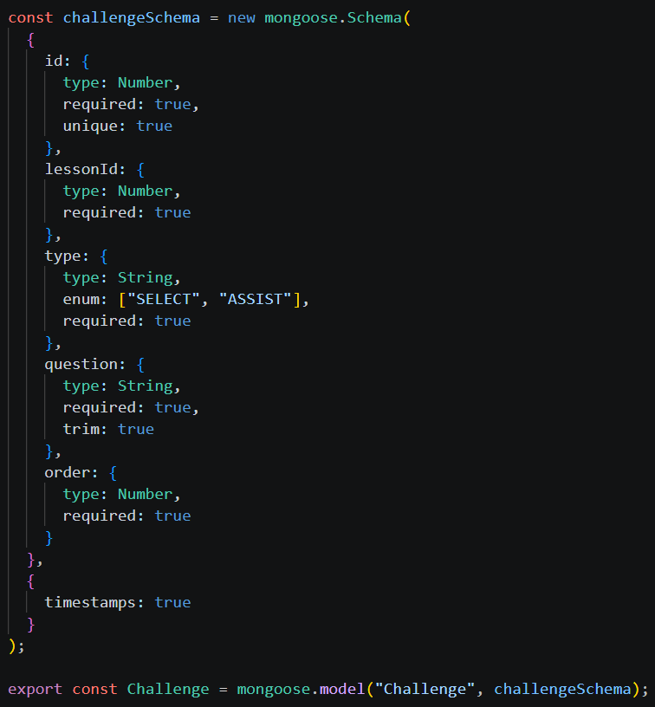

11.3.6 ChallengeOption.js — Schema for Answer Options
Fields: id (Number), challengeId (ObjectId, FK), text (String), correct (Boolean)

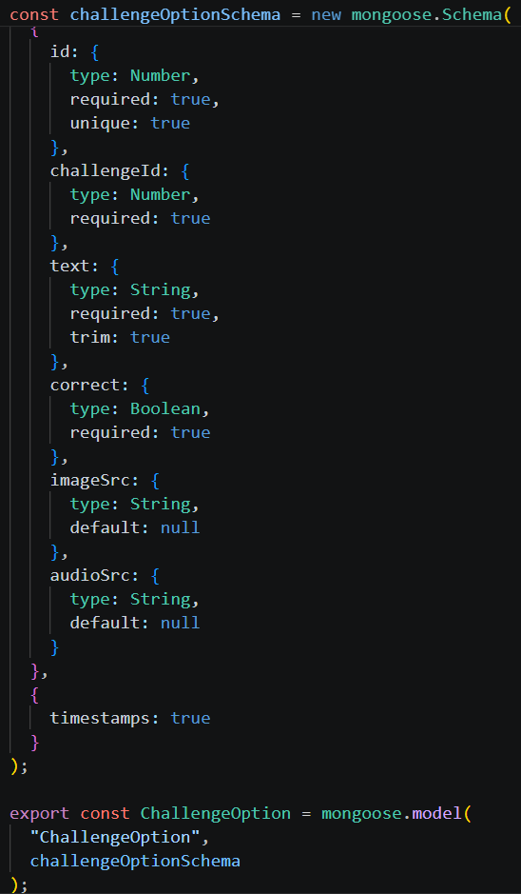

11.3.7 ChallengeProgress.js — Schema for User Progress
Fields: userId (ObjectId, FK), challengeId (ObjectId, FK), completed (Boolean), with composite unique index on (userId, challengeId)
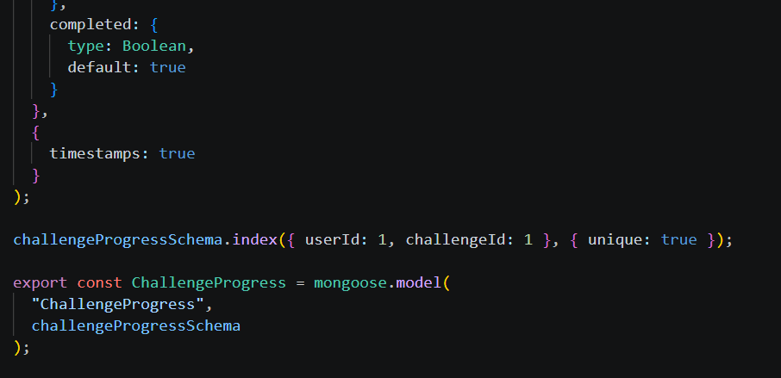

11.3.8 Counter.js — Schema for Auto-Incrementing IDs
Fields: key (String, unique), value (Number)
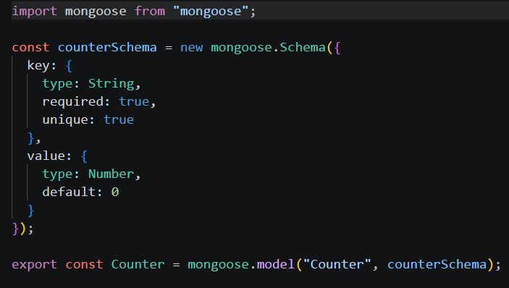
12. Frontend Development

[Frontend Structure Reference Link:]

12.1 Frontend Structure
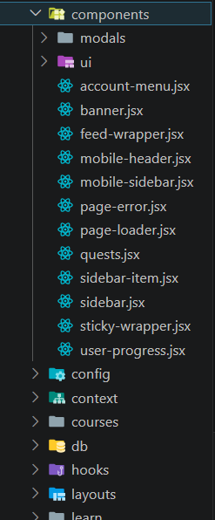
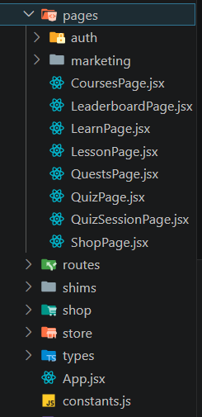
12.1.1 Pages (src/pages)
• SignUpPage.tsx — User registration form
• SignInPage.tsx — User login form
• LearnPage.tsx — Main learning dashboard
• CoursesPage.tsx — Course selection interface
• LessonPage.tsx — Lesson with challenges
• LeaderboardPage.tsx — Global rankings display
• ShopPage.tsx — Reward shop interface
• QuestsPage.tsx — Daily/weekly quests
• MarketingPage.tsx — Landing page

12.1.2 Components (Reusable Parts)
• components/modals/ — PracticeModal, HeartsModal, ExitModal
• components/ui/ — Button, Card, Input, ProgressBar, Avatar

12.1.3 State Management (store/)
• Uses Zustand for lightweight state management
• Stores: use-practice-modal.ts, use-hearts-modal.ts, use-exit-modal.ts

12.1.4 Custom Hooks (hooks/)
• useAsyncData.ts — Handle async data fetching
• useAuth() — Authentication logic
• useApi() — API call wrapper
• useUser() — User data access

12.1.5 Styling
• Tailwind CSS for utility-first styling
• Responsive design using Tailwind breakpoints
• Custom color scheme matching brand
• Mobile-first approach
• Landing Page: [Screenshot: Landing page with course selection and call-to-action]
• Registration Page: [Screenshot: Sign up page with email and password fields]
• Login Page: [Screenshot: Sign in page with authentication form]
• Learning Dashboard: [Screenshot: Main dashboard showing courses, units, progress, XP, and hearts]
• Lesson/Challenge Page: [Screenshot: Interactive challenge with question and multiple choice options]
• Leaderboard Page: [Screenshot: Global rankings showing top users by XP]
• Shop Page: [Screenshot: Reward shop with purchasable items]
• Quests Page: [Screenshot: Daily and weekly quests with progress tracking]

13.1 GitHub Repository
https://github.com/

13.2 Live Demo
[Live Demo URL — Deploy URL will be added here]

13.3 Quick Start Guide
1. Clone the repository: git clone https://github.com/
2. Navigate to project: cd ____
3. Set up frontend: cd client && npm install
4. Set up backend: cd ../server && npm install
5. Create .env files with appropriate values
6. Seed database: npm run seed
7. Start backend: npm run dev
8. Start frontend: cd ../client && npm run dev
9. Open http://localhost:5173

13.4 OUTPUT Screenshots:
SignUpPage.tsx :
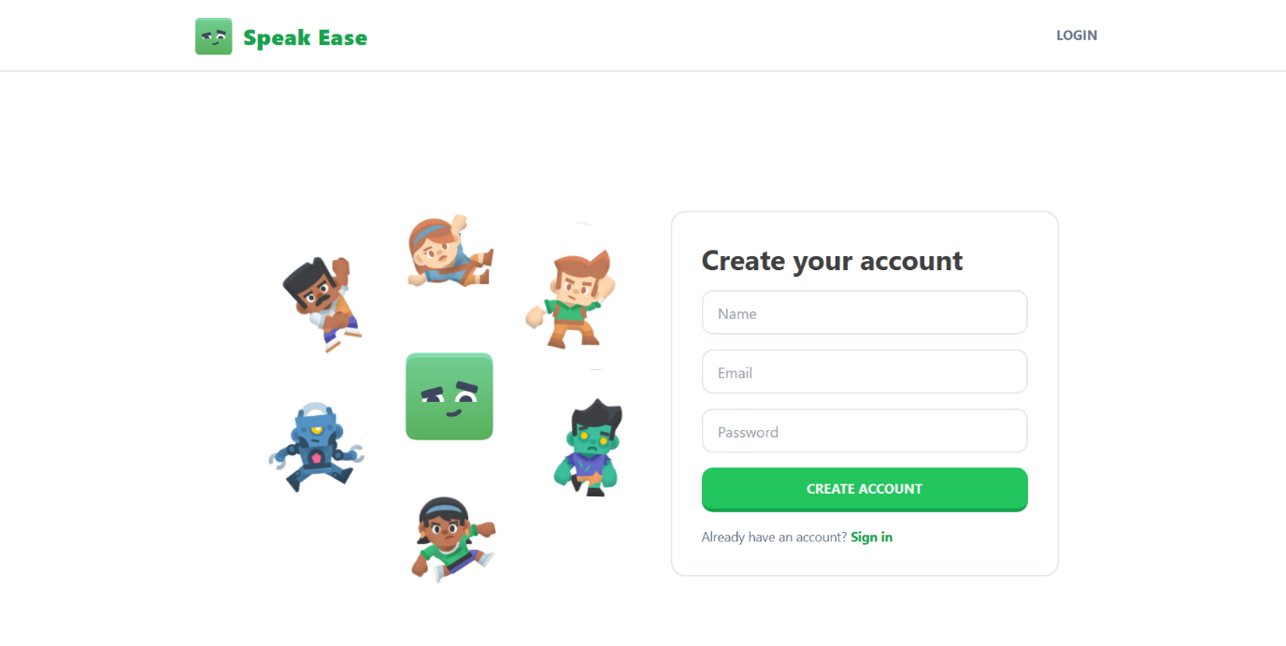
SignInPage.tsx :
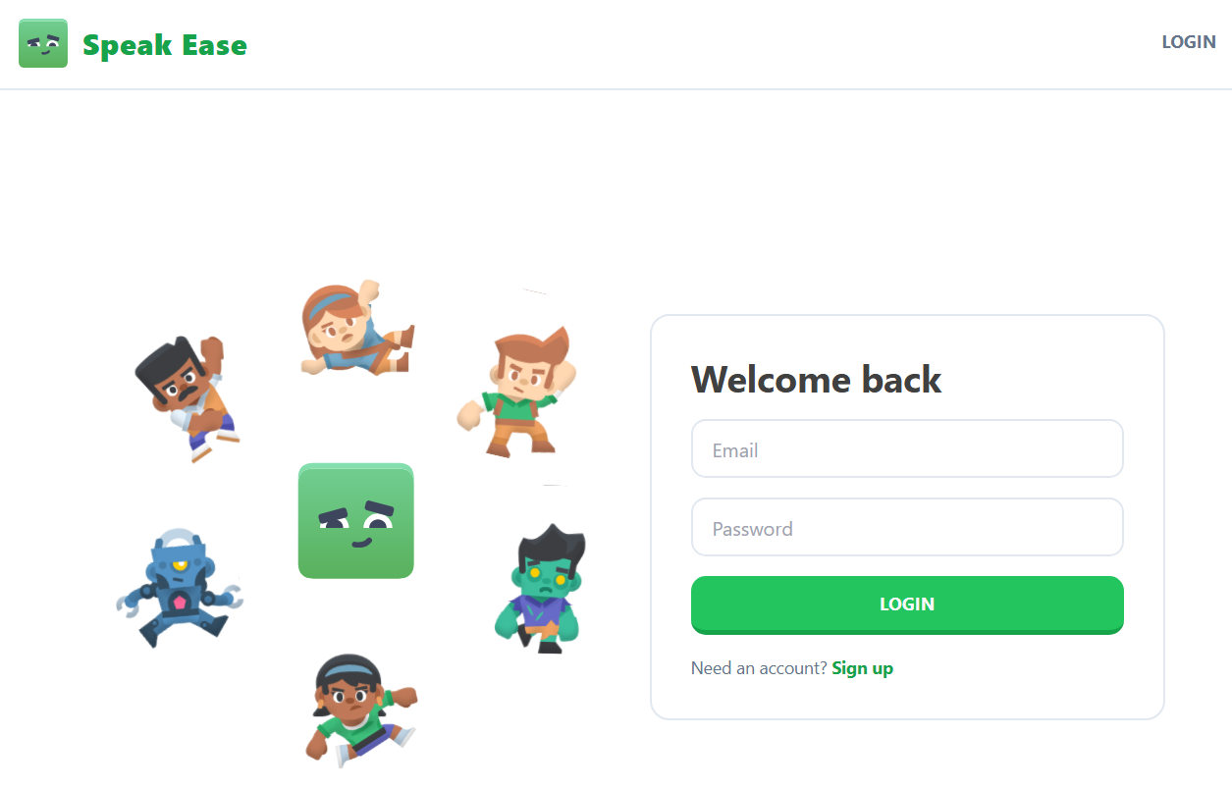
Home page :

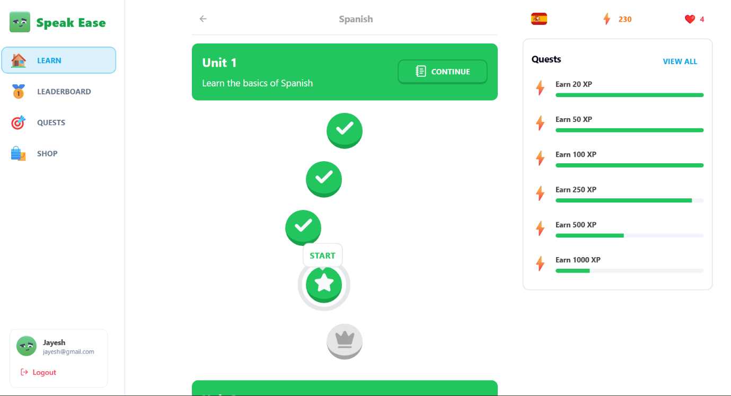

Leaderboard :
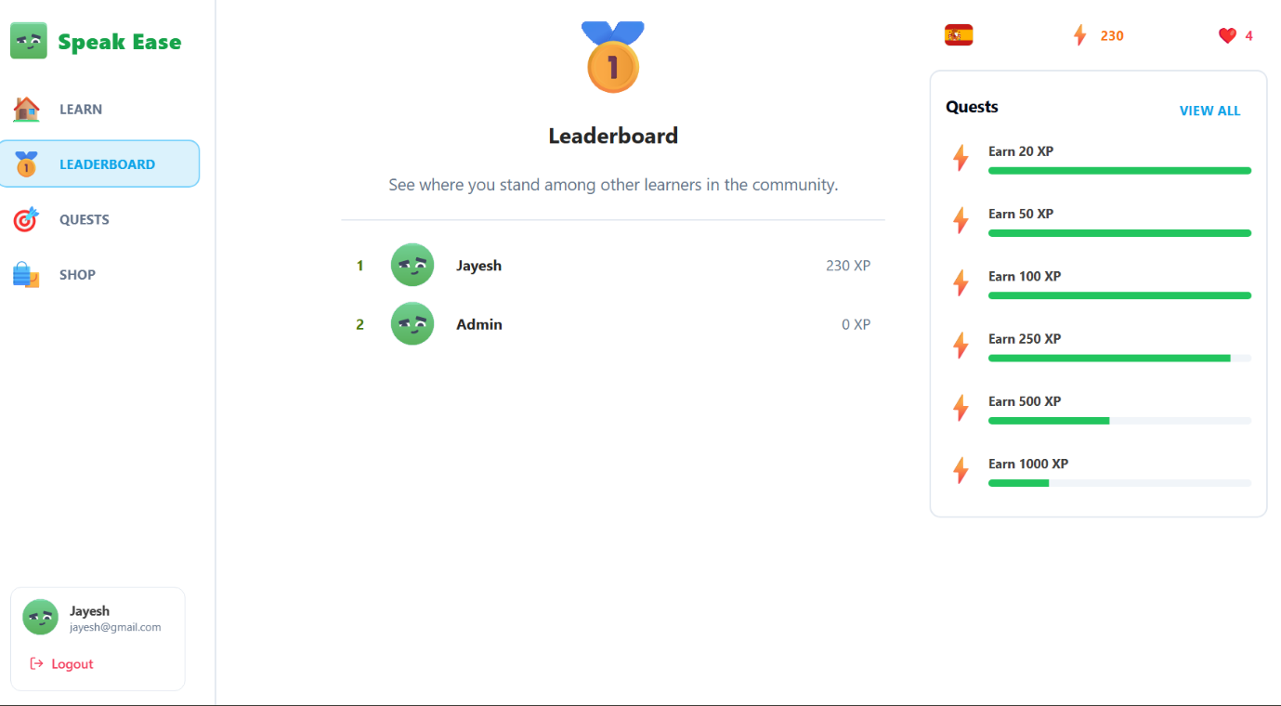

Quests :
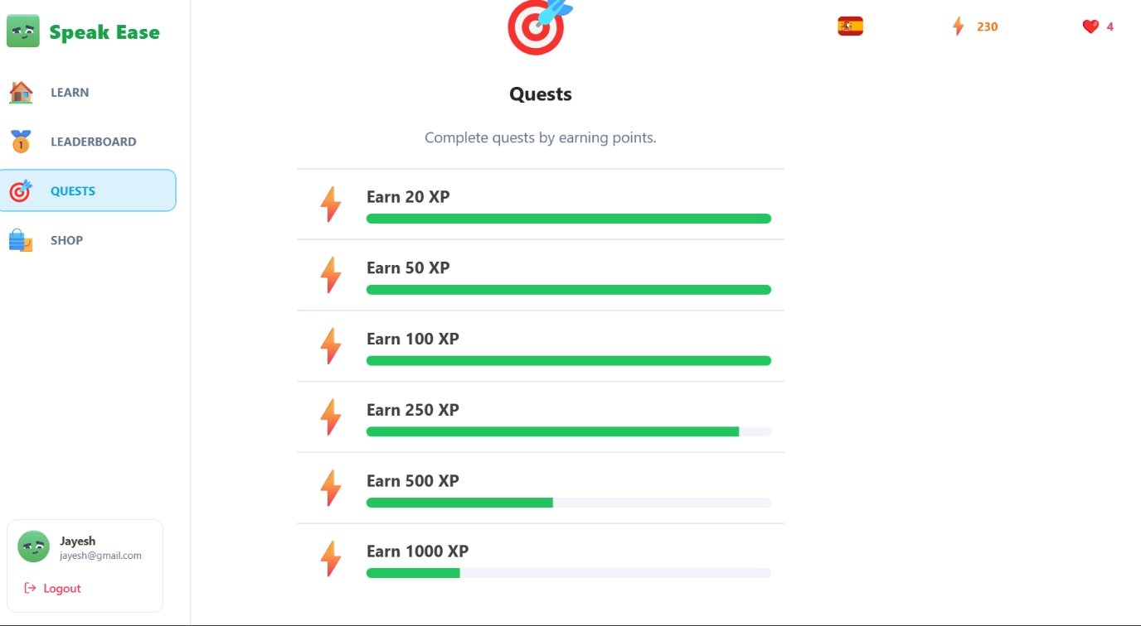

Shop :
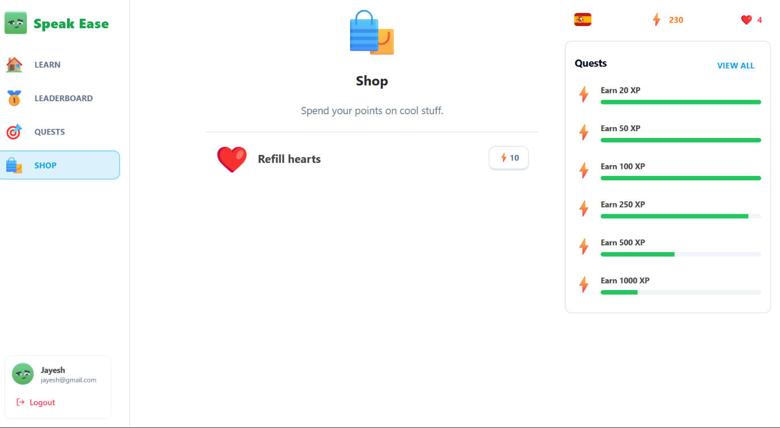

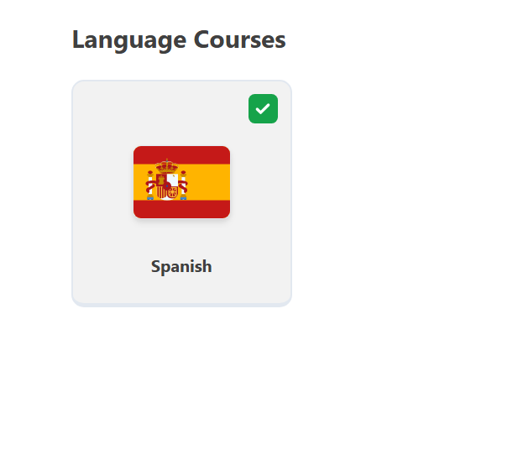
Languages :

Quizs :
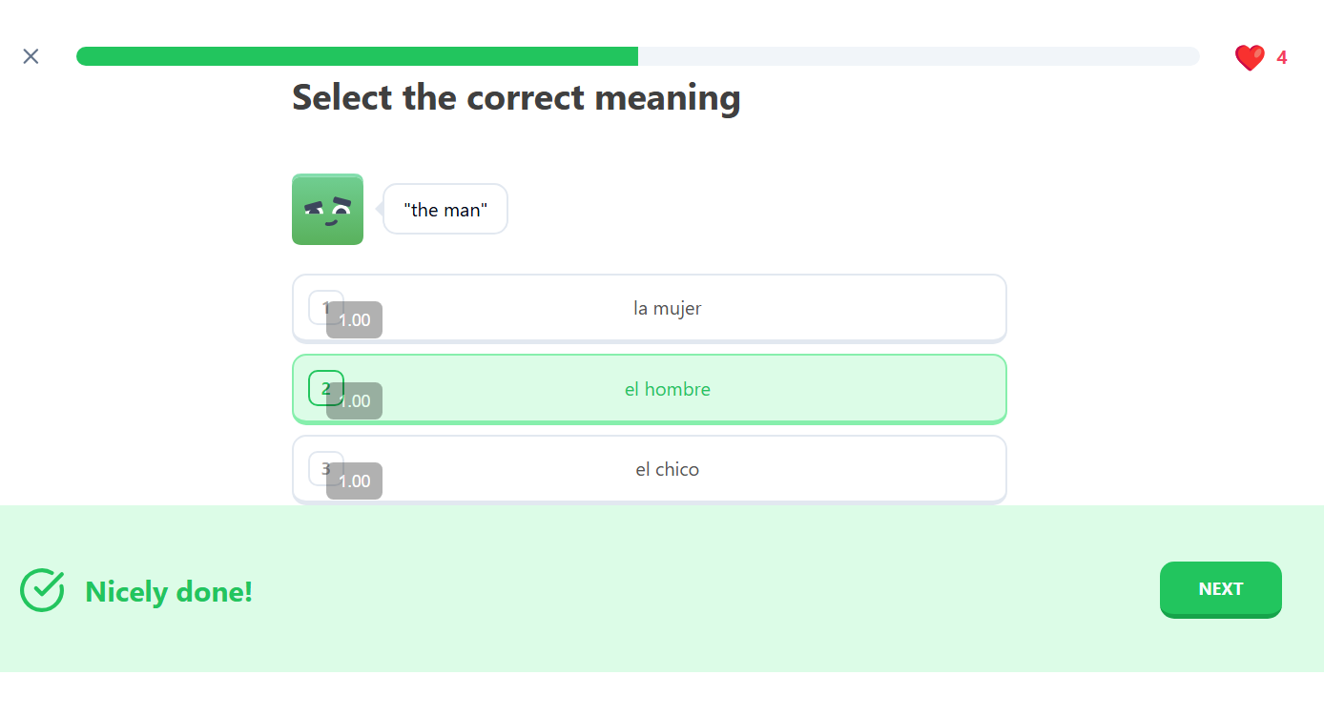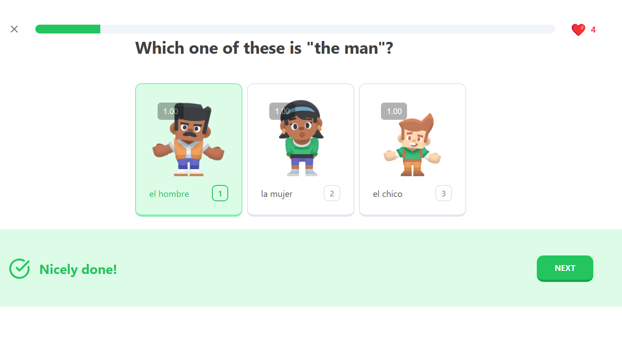

Result Page :


14. Technologies Used
14.5.1 Frontend
• React 19.2 — UI library
• Vite 7.1 — Build tool
• TypeScript 5.9 — Type safety
• Tailwind CSS 3.4 — Styling
• React Router 6.30 — Routing
• Zustand 5.0 — State management
• Radix UI — Accessible components
14.5.2 Backend
• Express.js 5.1 — Web framework
• Node.js — JavaScript runtime
• Mongoose 8.18 — MongoDB ODM
• JWT — Authentication
• bcryptjs — Password hashing
• CORS — Cross-origin requests
14.5.3 Database
• MongoDB 6.0+ — NoSQL database
• Mongoose — Schema validation

15. Conclusion
Speak-Ease represents a modern, full-stack approach to building gamified learning plat- forms. By combining structured content delivery with engaging gamification mechanics and community features, it creates an environment where users are motivated to learn consistently and achieve their language learning goals.
The architecture is scalable, maintainable, and built with industry best practices. The use of modern frameworks (React, Express, MongoDB) ensures performance and reliability. Whether you’re a learner seeking to improve your language skills or a developer interested in understanding a complete full-stack application, Speak-Ease provides valuable insights and a solid foundation for further development and customization.
Thank you for exploring Speak-Ease. We hope this documentation helps you understand, deploy, and contribute to the project.

© 2024 Speak-Ease. All Rights Reserved.

